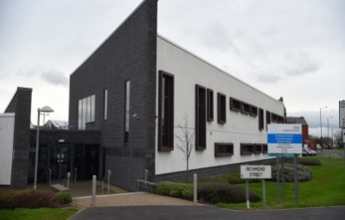
Arrival Medical Practice
Endurance House
Clarence Street
Stockton on Tees
TS18 2EP
Tel: 01642 615415
Email: arrival.practice@nhs.net

Guide to fees for Non NHS Services

Certificates, Letters and Forms

Private Sick Note £18.00

Life Insurance Form (no examination) £120.00

Medical Reports and Examinations

Medicals; HGV, Taxi, Insurance reports £120.00

Comprehensive Examination and Report £165.00

DNA Testing £50.00

Army Form £65.00

Solicitor, Home Office Reports Cost TBC upon request

Travel

Prescription drugs for the purpose of travel £10.00

Holiday cancellation certificate £25.00

Fitness to Travel (Holiday) £25.00

Why are fees charged?

The contract the practice has with NHS England and the CCG covers medical services to NHS patients. In recent years more and more organisations have been requesting Doctors to complete a wide range of non-NHS work and certification. This is often done to cover costs and apportion responsibility should an unexpected event occur.
This work is not funded by the government, so GP’s have to charge a fee to cover their time and other administrative expenses.

Surely the doctor is being paid any way?

It is important to understand that many GP’s are not employed by the NHS. They are self-employed and they have to cover costs of everything from the limited NHS Funds provided – staff wages, buildings, heating, lighting etc – in the same way any small business has to.

Do GP’s have to do non-NHS work for their patients?

GP’s do not have to carry out non-NHS work in the same way any business or contractor does not have to carry out work that you ask for. Many GP’s will however attempt to assist their patients with this work where it is in their area of knowledge, understanding and expertise.

What is covered by the NHS and what is not?

The Government's contract with GPs covers medical services to NHS patients, including the provision of ongoing medical treatment. In recent years, however, more and more organisations have been involving doctors in a whole range of non-medical work.
Sometimes the only reason that GPs are asked is because they are in a position of trust in the community, or because an insurance company or employer wants to ensure that information provided to them is true and accurate.
Examples of non-NHS services for which GPs can charge their own NHS patients are:
- accident/sickness certificates for insurance purposes.
- reports for health clubs to certify that patients are fit to exercise.
- pre-employment medicals, as requested by employers.
Examples of non-NHS services for which GPs can charge other institutions are:
- life assurance and income protection reports for insurance companies.
- reports for the Department for Work and Pensions (DWP) in connection with disability living allowance and attendance allowance.
- medical reports for local authorities in connection with adoption and fostering.

Why does it sometimes take my GP a long time to complete my form/letter?

Time spent completing forms and preparing reports takes the GP away from the medical care of patients which will always have top priority. GP have an ever increasing workload of forms/letters/reports and certificates which must be prioritised against offering appointments and other urgent administrations like referrals and results. We aim to complete non-NHS work within two weeks of receipts but this is in no way guaranteed and may be closer to 3 weeks at times. Copy records may take up to 4 weeks to complete.

I only need the GP’s signature – what’s the problem?

When a GP signs a certificate, letter or report it is a condition of legality and of remaining on the medical register (which allows them to practice as a doctor), that they only sign what they know to be factually true. In order to complete even the simplest of forms, the doctor needs to read the entire medical record. They also need to have medical indemnity insurance which for a Full time GP is approximately £10,000 - £12,000 per annum and is paid by them.

